The Lord’s Prayer
As our Saviour taught us, so we pray,

We pray the Lord’s Prayer in its contemporary form.
Breaking of the Bread

We break the bread of life, and that life is the light of the world. God here among us, light in the midst of us, bring us to light and life, in the body of Christ.

Invitation to Communion

Christ is the true bread which came down from heaven.
Lord, give us this bread always.

The president receives Holy Communion in both kinds and invites those present and at home to make a spiritual communion.

A hymn or song is played.

Prayer after Communion
Silence is kept.
Let us pray.

The president prays the Post Communion Prayer.
Notices and Banns of Marriage

The Blessing
and Dismissal
Christ our Lord,
to whom kings bowed down in worship and offered gifts,
reveal to you his glory
and pour upon you the riches of his grace;
and the blessing …

Go in peace. Proclaim the Word made flesh. Glory, thanks and praise to God. Amen
A hymn is sung as Holy Communion is administered.
*********

Holy Communion will be administered in one kind as you leave to those who wish to receive. Please leave church following the direction arrows and please sanitise your hands as you leave.
Please take this sheet home with you.

Material for this service is taken from Common Worship: Services and Prayers for the Church of England Published by Church House Publishing,London Copyright The Archbishops’ Council, 2000
In accordance with Tier 4 restrictions we ask you not to socially gather with people from other households either in church or in the church car park

Team Eucharist for Sunday 3 January 2021

St Stephen’s, Astley

Epiphany

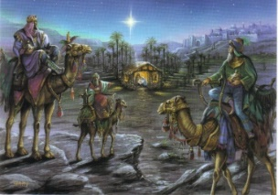

Gathering

We meet in the name of the Father, the Son and the Holy Spirit. Amen.

A welcome is given and the service is introduced

Lord Jesus Christ, your birth at Bethlehem draws us to kneel in wonder at heaven touching earth: accept our heartfelt praise as we worship you, our Saviour and our eternal God. Amen
A hymn or song is played.

Confession
The president invites us to say sorry to God.

The grace of God has dawned upon the world
through our Saviour Jesus Christ,
who sacrificed himself for us to purify a people as his own. Let us confess our sins.

Lord, have mercy. Lord, have mercy.

Christ, have mercy. Christ, have mercy.

Lord, have mercy. Lord, have mercy.

We are assured of God’s forgiveness.

Collect
The president prays the Collect of the day.
Let us pray.
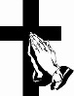

Ministry of the Word

We hear readings from both the Old Testament and the New Testament.

At the end of the readings.
For the word of the Lord.
Thanks be to God.

A hymn or song is played.
Reading of the Gospel
Please stand
Alleluia, alleluia.
Christ was revealed in flesh, proclaimed among the nations and believed in throughout the world.
Alleluia.

Hear the Gospel of our Lord Jesus Christ according to Matthew. Glory to you, O Lord.

Matthew 2 vv 1-12 The Visit of the Magi

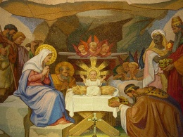

This is the Gospel of the Lord
Praise to you, O Christ.

Address
A minister shares with us.

Affirmation of Faith
Please stand.

Let us declare our faith in God, Father, Son and Holy Spirit.

We believe in God the Father from whom every family in heaven and on earth is named.

We believe in God the Son, who lives in our hearts through faith, and fills us with his love.

We believe in God the Holy Spirit, who strengthens us with power from on high.

We believe in one God; Father, Son and Holy Spirit. Amen.

Prayers of Intercession

At the end.
Merciful Father, accept these prayers for the sake of your Son, our Saviour Jesus Christ. Amen.

The Peace
We remain seated
The president introduces the peace.
The peace of the Lord be always with you.
And also with you.

We remain seated.

Ministry of the Sacrament

Lord, accept your people’s gifts,
not gold, frankincense or myrrh,
but hearts and voices raised in praise
of Jesus Christ, our light and our salvation.

The Lord is here.
His Spirit is with us.

Lift up your hearts.
We lift them to the Lord.

Let us give thanks to the Lord our God.
It is right to give thanks and praise.

The president praises God for his wonderful acts.

Holy, holy, holy Lord, God of power and might, heaven and earth are full of your glory. Hosanna in the highest. Blessed is he who comes in the name of the Lord. Hosanna in the highest.

The president remembers Jesus’ actions at the Last Support

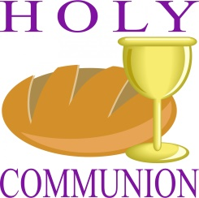
Jesus Christ is Lord: Lord, by your cross and resurrection
you have set us free.
You are the Saviour of the world.
The president prays for the empowering of the Holy Spirit.

