**Children's Quiz Page**

1. How many teeth do elephants use to chew food?

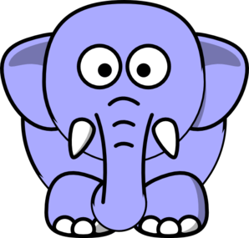

a)4 b)32 c)56

2. Which is the most popular pet worldwide?

a)cat b)dog c)fish

3. How was Marie Antoinette executed during the French Revolution/

a)hangman b)guillotine c)bagatelle

4. Where would you find a manga?

a)in a circus

b)in a fruit market

c)in a comic book store

5. Which dogs pull snow sleds?

a)poodles

b)huskies

c)bloodhounds

6. What makes up 70% of the human body?

a)carbon

b)water

c)calcium

7. What's the biggest planet in the Solar System?

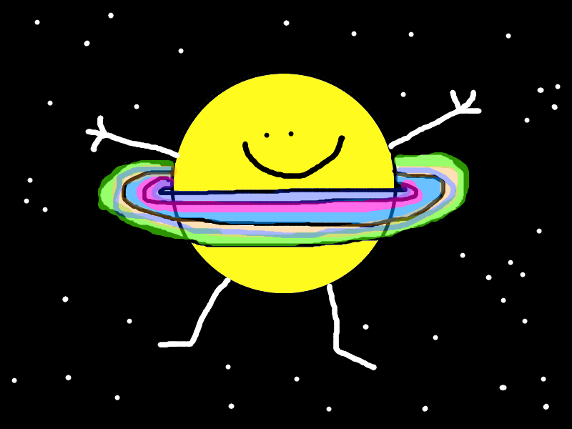

a)Uranus

b)Jupiter

c)Saturn

8. What did the ancient Romans use to clean themselves?

a)olive oil

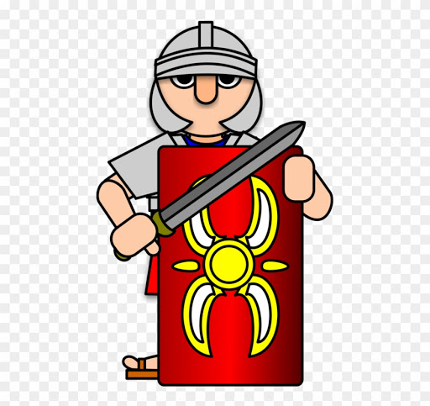

b)wine

c)soap

9. What destroyed large patches of London in 1666?

a)fire

b)earthquake

c)flood

10. What melts ice?

a)salt

b)pepper

c)yeast

11. How many legs do spiders have?

a)6

b)8

c)10

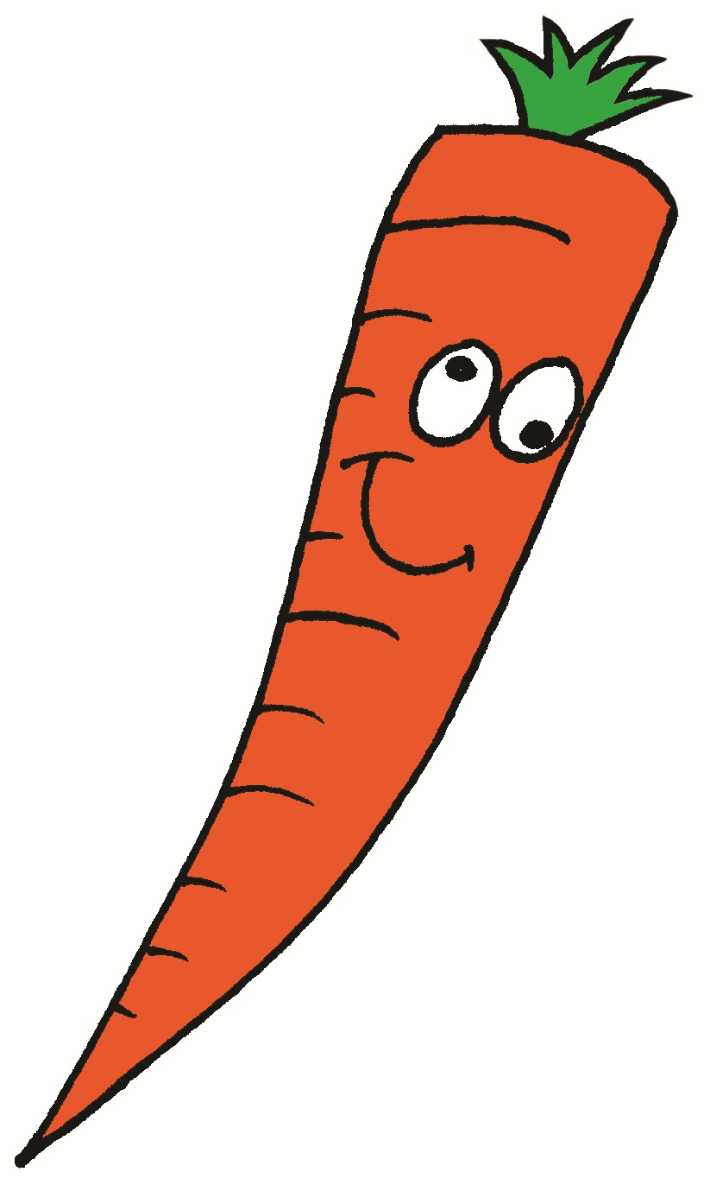

12. Which is not a vegetable?

a)pear

b)carrot

c)onion

12.a

13.c

14.c

13. What is the highest mountain in Africa?

a)The Matterhorn

b)Mount Everest

c)Kilimanjaro

14. If you sneezed in Germany, what would somebody say?

a)Schnitzel!

b)Lederhosen!

c)Gesundheit!

Answers

1.a

2.a

3.b

4.c

5.b

6.b

7.b

8.a

9.a

10.a

11.a