An Astley Walk (approx 5 miles – easy walking)

Starting from the Miners Welfare car park at Gin Pit cross Meanley Road and find a narrow path on the right and go onto the field at the side of the houses. This area is known as Colliers Wood. Walk along the path almost to the end, when you will start to see the houses of Higher Folds.

Turn left, just before you get to the estate, and follow the path through the woods until you come to a cross paths. Go straight across and up the slight hill and then down to the stile at the bottom of the hill. Go over the stile and down the short path then turn left.

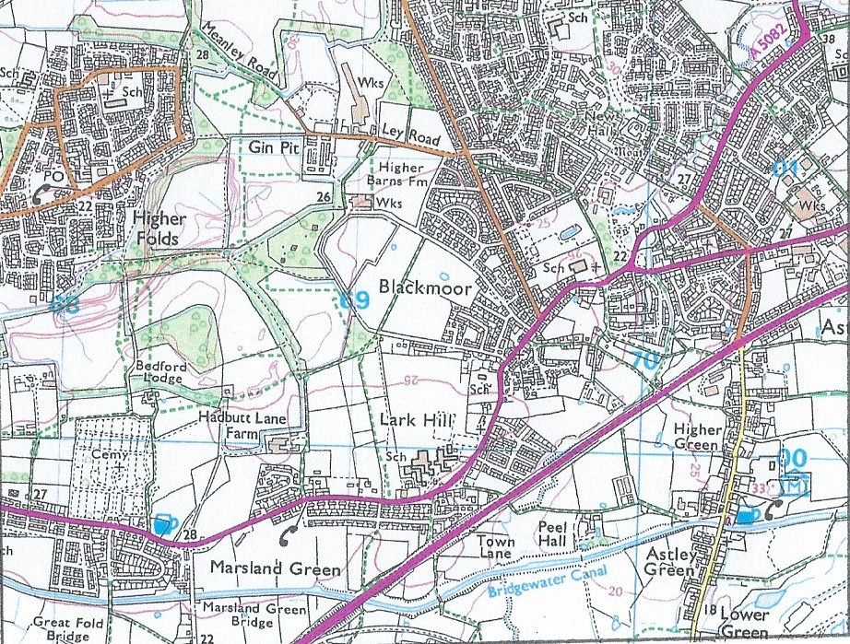

Keeping the back of the cemetery on your right walk to the end and to a dirt track. Turn right and follow the track and then the road to the end. You will have arrived at Manchester Road.

Turn left heading back towards Astley but cross Manchester Road at Marsland Green and walk down this lane. Go over the bridge then turn left onto the canal towpath. Once on the towpath, and keeping canal on your left, keep going until you get to the Old Boathouse pub at Lower Green. Then leave the towpath go up Lower Green Lane, past the Mining Museum to the East Lancs Road.

Cross the East Lancs and carry on straight up to Cross Hillocks – turn left and walk along Manchester Road, past the Bulls Head and St Stephen’s Church to North Lane ( just past Astley Tandoori). Turn right up North Lane and walk to the end where you will see the Bed Factory. Then turn right and go down a dirt track and follow it to the bus lay-by on Ley Road. Turn left onto Ley Road and walk up to the Miners Welfare and voila you are back at your car!

Jenny Evans

