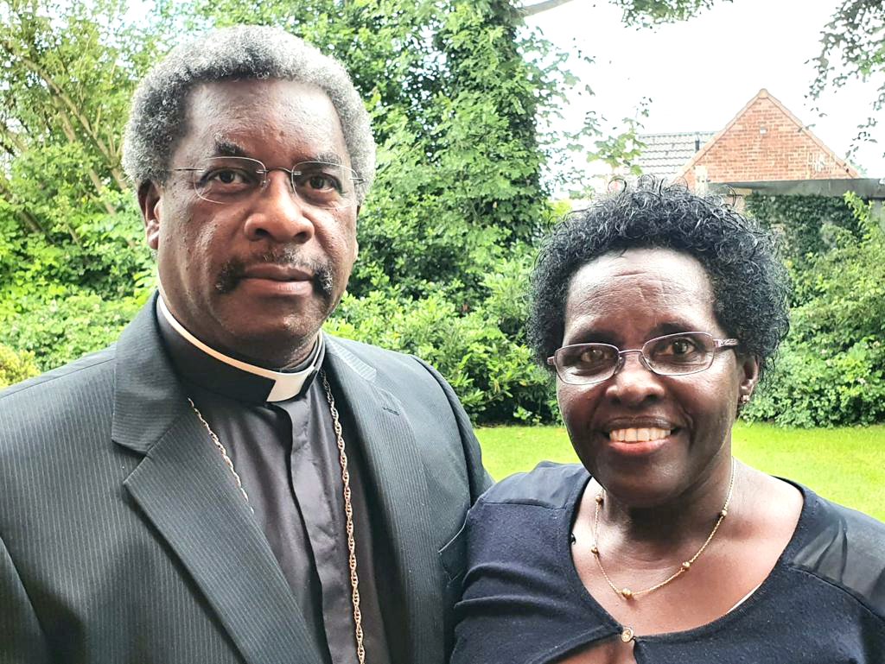

“Enjoy God, enjoy yourself and let people enjoy the gifts that God has given to you.”

Born and raised in Rwanda, East Africa, I have been in ministry since 1982 when I was ordained and consecrated in the Anglican Church of Rwanda. My wife, Asnath Mukamabano, and I have 3 adult children – a daughter and two sons, as well as a very energetic 5-year old grandson.

Our ministry is a family ministry - I started the ministry with my wife, a nurse by profession, and when God blessed us with children, they joined us in His ministry and mission.

After serving in the Church of Rwanda, my family and I moved to Canada in 1997 on sabbatical leave. In 1998, we moved to Cameroon, West Africa, on mission and came to the UK in January 2004, as I took on a study leave at Crowther Hall (CMS Centre for Management and Mission Studies) in Birmingham. I had the pleasure to serve in 4 Team Ministries in the Droitwich Deanery, Worcester Diocese from May 2005 until August 2014.

In my spare time, I enjoy reading, photography, DIY and watching football (a Manchester United fan). Asnath on the other hand prefers to not support one team over the other, loves flowers, gardening and together we enjoy walking and sight-seeing when we can.

We are certain that God has a purpose for sending us among you. Asnath and I are very happy and excited to be among you dear brothers and sisters, to grow spiritually together with you, to use the gifts God has given to each one of us for the good of the Church, the nation and the whole world, and to enjoy God’s goodness and love with you. Jonathan Ruhumuliza

