Parish Church of St George, Tyldesley

Feast of Corpus Christi

Sunday, 14 June 2020

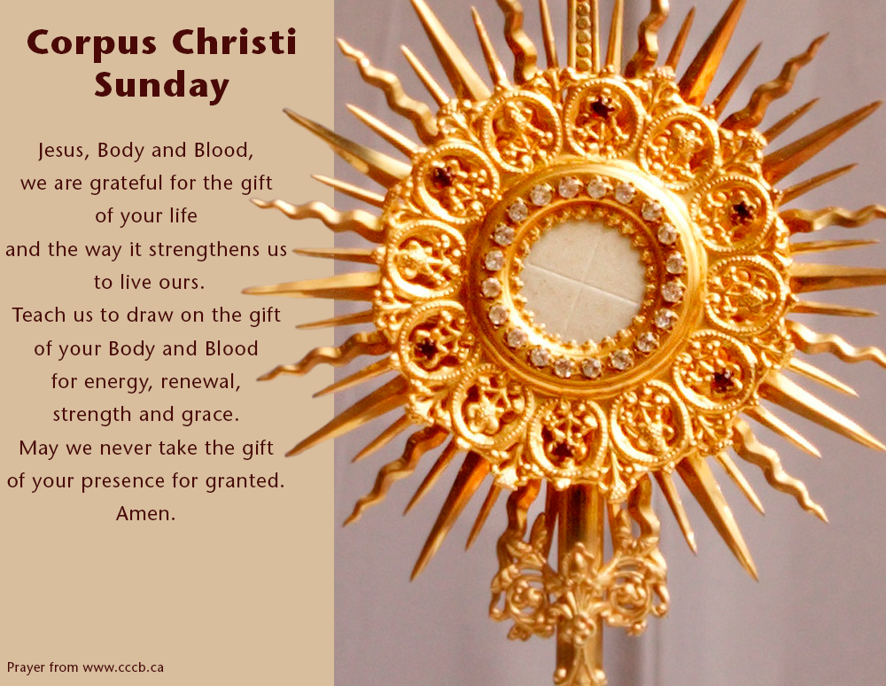

Prayers of Intercession

Astley, Tyldesley and Mosley Common Team Ministry

“Together in worship, love and service”

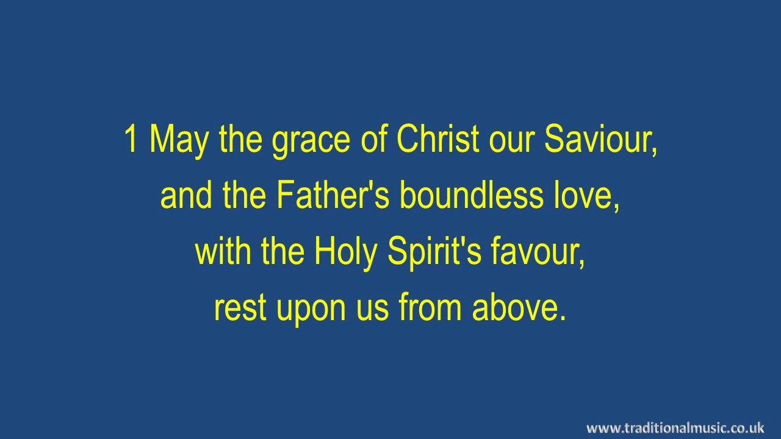

***May the grace of Christ our Saviour,***

***And the Father’s boundless love,***

***With the Holy Spirit’s favour,***

***Rest upon us from above.***

***Thus, may we abide in union***

***With each other and the Lord,***

***And possess in sweet communion,***

***Joys which earth cannot afford.***

***To the God whose wisdom made us,***

***To the Son who set us free,***

***To the sanctifying Spirit,***

***Glory, endless glory, be! Amen.***

John Newton 1725-1807

#### Collect:

Lord Jesus Christ,

we thank you that in this wonderful sacrament

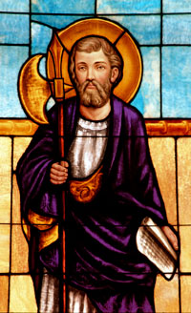you have given us the memorial of your passion:

grant us so to reverence the sacred mysteries

of your body and blood

that we may know within ourselves

and show forth in our lives

the fruits of your redemption;

for you are alive and reign with the Father

in the unity of the Holy Spirit,

one God, now and for ever.

#### What Does Genesis 14:18 Mean?Genesis 14.18-20

And King Melchizedek of Salem brought out bread and wine; he was priest of God Most High.

He blessed him and said,

“Blessed be Abram by God Most High,   
    maker of heaven and earth;  
and blessed be God Most High,[[c](https://www.biblegateway.com/passage/?search=Genesis+14%3A18-20&version=NRSV#fen-NRSV-357c)]  
    who has delivered your enemies into your hand!”

And Abram gave him one-tenth of everything.

#### Psalm 116.10-17

I kept my faith, even when I said,  
    “I am greatly afflicted”;  
I said in my consternation,  
    “Everyone is a liar.”

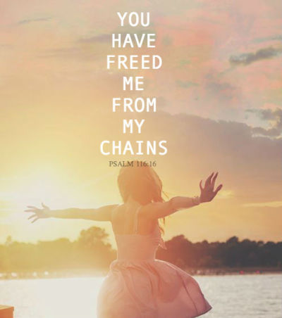What shall I return to the Lord  
    for all his bounty to me?  
I will lift up the cup of salvation  
    and call on the name of the Lord,   
I will pay my vows to the Lord  
    in the presence of all his people.  
Precious in the sight of the Lord  
    is the death of his faithful ones.  
O Lord, I am your servant;  
    I am your servant, the child of your serving girl.  
    You have loosed my bonds.  
I will offer to you a thanksgiving sacrifice  
    and call on the name of the Lord.

#### 1 Corinthians 11.23-26

**The Institution of the Lord’s Supper**

For I received from the Lord what I also handed on to you, that the Lord Jesus on the night when he was betrayed took a loaf of bread, and when he had given thanks, he broke it and said, “This is my body that is for[[a](https://www.biblegateway.com/passage/?search=1+Corinthians+11%3A23-26&version=NRSV#fen-NRSV-28609a)] you. Do this in remembrance of me.”In the same way he took the cup also, after supper, saying, “This cup is the new covenant in my blood. Do this, as often as you drink it, in remembrance of me.”For as often as you eat this bread and drink the cup, you proclaim the Lord’s death until he comes.

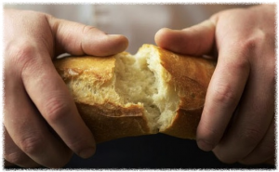

***Bread of the world, in mercy broken,  
Wine of the soul, in mercy shed,  
 By whom the words of life were spoken,  
And in whose death our sins are dead.***

***Look on the heart by sorrow broken,  
Look on the tears by sinners shed;  
And be your feast to us the token,***

***That by your grace our souls are fed.***

*Re­gi­nald He­ber (1783–1826),*

#### The Gospel of John 6.51-58

I am the living bread that came down from heaven. Whoever eats of this bread will live forever; and the bread that I will give for the life of the world is my flesh.”

The Jews then disputed among themselves, saying, “How can this man give us his flesh to eat?” **53**So Jesus said to them, “Very truly, I tell you, unless you eat the flesh of the Son of Man and drink his blood, you have no life in 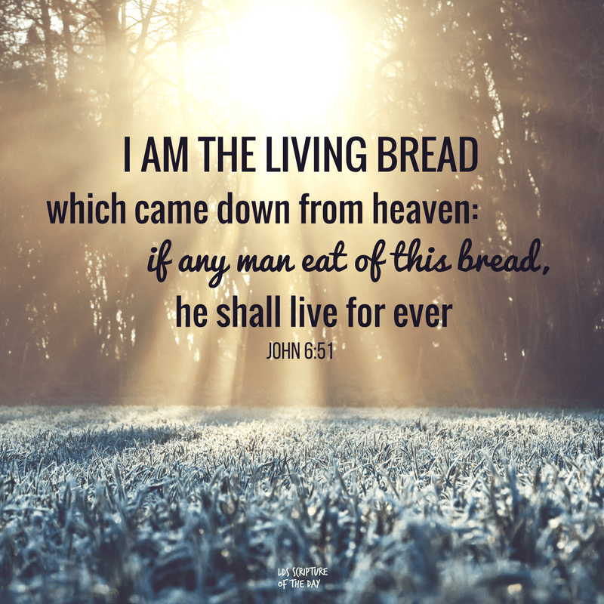you. Those who eat my flesh and drink my blood have eternal life, and I will raise them up on the last day; for my flesh is true food and my blood is true drink. Those who eat my flesh and drink my blood abide in me, and I in them.Just as the living Father sent me, and I live because of the Father, so whoever eats me will live because of me. This is the bread that came down from heaven, not like that which your ancestors ate, and they died. But the one who eats this bread will live forever.”

#### Intercessions:

Lod, we encounter your love

**In the breaking of bread**

**And the pouring of wine**

Sometimes, we are not certain why we come – habit , duty, the easiest option?

Sometimes the hymns are empty, the words are dull, and we don’t really concentrate.

Quite often the mind wanders off - to the Sunday papers, or what has to bedone this afternoon.

Wouldn’t it be nice to bea happy pagan?

But then, Lord

we encounter your love

**In the breaking of bread**

**And the pouring of wine**

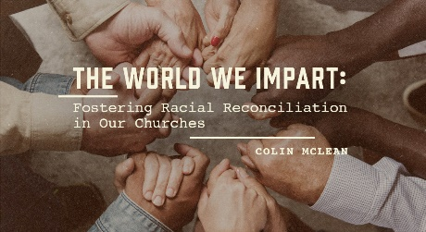Around us is a world of extraordinary wonder and terror

People are discovering love and using it

Some are striding forward confidently and others are walkig on broken glass

Some are full of hope, and some are crushed and exhausted

And always the burnin, ressing beauty of God is coming to meet us

we encounter your love

**In the breaking of bread**

**And the pouring of wine**

Each of us brings our own special people to this service, carrying them in our hearts:

The child we despair of, and the child we long for;

The parent we love and sometimes resent, but who can no longer live alone

the friend whose cancer has wrecked her life.

We bring them with us, Lord, because

we encounter your love

**In the breaking of bread**

**And the pouring of wine**

In our deepest places there are hidden fears, and thoughts, we admit to no one.

All our vulnerability is exposed there; all the darkness which waits in our dreams

Perhaps we can begin to see that nothing is unknown to you, and that you look with mercy, not with blame

We come ourselves, Lord

to encounter your love

**In the breaking of bread**

**And the pouring of wine**

Gracious God, in this service we come to break bread for the city and pour wine for the world

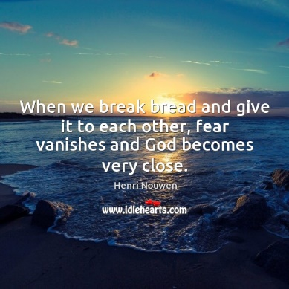We break bread for our sin and pour wine for our celebration

We break bread for each other and pour wine for for your Kingdom.

Bless us and all those for whom we pray,

that, we encounter your love

**In the breaking of bread**

**And the pouring of wine**

#### 

#### A reflection on Corpus Christi

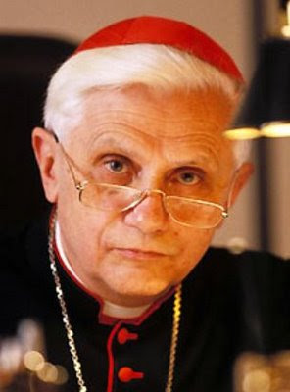 What does Corpus Christi mean to me?

It does not only bring the liturgy to mind; for me, it is a day on which heaven and earth work together.

In my mind’s eye it is the time when spring is turning into summer; the sun is high in the sky, and crops are ripening in field and meadow.

The Church’s feasts make present the mystery of Christ, but Jesus Christ was immersed in the faith of the people of Israel and so, arising from this background in Israel’s life, the Christian feasts are also involved with the rhythm of the year, the rhythm of seedtime and harvest.

How could it be otherwise in a liturgy which has at its centre the sign of bread, fruit of earth and heaven? Here this fruit of the earth, bread, is privileged to be the bearer of him in whom heaven and earth, God and man have become one.

The way the Church’s feasts fit in with the seasons of the year is therefore not an accident. Consequently, we must go on to discover the inner rhythm of the Church’s year and see the place Corpus Christi has within it.

First of all, clearly, it grows out of the mystery of Easter and Pentecost: it presupposes the Resurrection and the sending of the Spirit.

But it is also in close proximity to the Feast of the Trinity, which reveals the inner logic in the connection between Easter and Pentecost.

It is only because God himself is the eternal dialogue of love that he can speak and be spoken to.

Only because he himself is relationship can we relate to him; only because he is love can he love and be loved in return.

Only because he is threefold can he be the grain of wheat which dies and the bread of eternal life.

Ultimately, then, Corpus Christi is an expression of faith in God, in love, in the fact that God is love.

All that is said and done on Corpus Christi is in fact a single variation on the theme of love, what it is and what it does.

In one of his Corpus Christi hymns Thomas Aquinas puts it beautifully: nec sumptus consumitur - love does not consume: it gives and, in giving, receives.

And in giving it is not used up but renews itself.

Since Corpus Christi is a confession of faith in love, there is hope.

And hope gives us the strength to live and face the world.

Joseph Cardinal Ratzinger

(later Pope Benedict XV!)



***In Christ alone my hope is found,  
He is my light, my strength, my song  
This Cornerstone, this solid Ground  
Firm through the fiercest drought and storm.  
What heights of love, what depths of peace  
When fears are stilled, when strivings cease  
My Comforter, my All in All  
Here in the love of Christ I stand.***

***In Christ alone! - who took on flesh,  
Fullness of God in helpless babe.  
This gift of love and righteousness,  
Scorned by the ones He came to save  
Till on that cross as Jesus died,  
The wrath of God was satisfied  
For every sin on Him was laid  
Here in the death of Christ I live.***

***There in the ground His body lay,  
Light of the world by darkness slain:  
Then bursting forth in glorious day  
Up from the grave He rose again  
And as He stands in victory  
Sin's curse has lost its grip on me,  
For I am His and He is mine  
Bought with the precious blood of Christ***

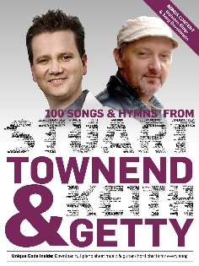

***No guilt in life, no fear in death,  
 This is the power of Christ in me  
From life's first cry to final breath,  
Jesus commands my destiny  
No power of hell, no scheme of man,  
Can ever pluck me from His hand***  
Till He returns or calls me home  
Here in the power of Christ I'll stand.

*Stuart Townend*

+++++++++++++

Anyone who has walked past church recently, should have seen the tremendous improvements being made as Frank and Carl plant bushes and shrubs in the churchyard garden. If any parishioners can donate cuttings or plants please contact me !!

text 07976 314012 and I’ll arrange for them to be collected.



***“Rooted in God’s love,***

***Growing together with Jesus,***

***Ministering in the power of the***

***Holy Spirit.”***

