Parish Church of St George, Tyldesley

Feast of Pentecost – Whit Sunday

Sunday, 31 May 2020

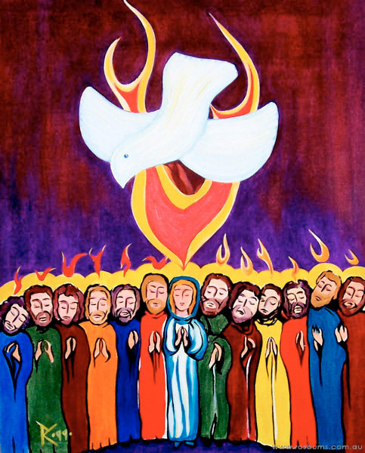

Prayers of Intercession

Astley, Tyldesley and Mosley Common Team Ministry

“Together in worship, love and service”

Holy Spirit, come as fire, and burn away the sins that cling to our church:

… come as fire, and burn away the conflicts that ivide and depress us

… come as fire, and burn away our pettiness, out insularity, our small gospel

…come as fire,

Contemplative silence

*Send us your Holy Spirit*

***Renew the earth.***

Holy Spirit, come as wind, and blow away the orderliness that tries to consign you to a box:

… come as wind and disturb our best-laid plans which left you out

… come as storm, and rage through our hypocrisy and cowardice till all is clean

… come as wind,

Contemplative silence

*Send us your Holy Spirit*

***Renew the earth.***

Holy Spirit, come as floodtide, and water the dry-ground we call our spirituality:

*…* come as floodtide, and sweep away our ramshackle defences against our love

… come as floodtide, and fill every nook and cranny of our lives

…come as floodtide

Contemplative silence

*Send us your Holy Spirit*

***Renew the earth.***

Holy Spirit, come as life-giver, and show us again, that basic choice – life or death, blessing or curse:

… come as life-giver nd build our confidence tht the last word in a resurrection faith is always ‘life’

… come as life-giver and breathe on all who are frail and weary, saddened and mourning,

… come as life-giver, and touch our jaded faith with the miracle of Christ

… come as life-giver

Contemplative silence

*Send us your Holy Spirit*

***Renew the earth.***



Spirit of the living God, fall afresh on us,

Spirit of the living God, fall afresh on us,

Break us, melt us, mould us, fill us

Spirit of the living God, fall afresh on us.

.

Merciful father:

**accept these prayers for the sake of your Son, our Saviour, Jesus Christ.  Amen**

**THE COLLECT**

Holy Spirit, sent by the Father,

ignite in us your holy fire;

strengthen your children with the gift of faith,

revive your Church with the breath of love,

and renew the face of the earth,

through Jesus Christ our Lord.

**THE EPISTLE** Acts 2:1-11 (NRSV)

**The Coming of the Holy Spirit**

2 When the day of Pentecost had come, they were all together in one place. 2And suddenly from heaven there came a sound like the rush of a violent wind, and it filled the entire house where they were sitting. 3Divided tongues, as of fire, appeared among them, and a tongue rested on each of them. 4All of them were filled with the Holy Spirit and began to speak in other languages, as the Spirit gave them ability.

5Now there were devout Jews from every nation under heaven living in Jerusalem. 6And at this sound the crowd gathered and was bewildered, because each one heard them speaking in the native language of each. 7Amazed and astonished, they asked, ‘Are not all these who are speaking Galileans? 8And how is it that we hear, each of us, in our own native language? 9Parthians, Medes, Elamites, and residents of Mesopotamia, Judea and Cappadocia, Pontus and Asia, 10Phrygia and Pamphylia, Egypt and the parts of Libya belonging to Cyrene, and visitors from Rome, both Jews and proselytes, 11Cretans and Arabs—in our own languages we hear them speaking about God’s deeds of power.’

**THE GOSPEL** Luke 24.44-53

**The Promise of the Holy Spirit**

15 ‘If you love me, you will keep[[f](https://www.biblegateway.com/passage/?search=john+14&version=NRSVA#fen-NRSVA-26673f)] my commandments. 16 And I will ask the Father, and he will give you another Advocate,[[g](https://www.biblegateway.com/passage/?search=john+14&version=NRSVA#fen-NRSVA-26674g)] to be with you for ever. 17 This is the Spirit of truth, whom the world cannot receive, because it neither sees him nor knows him. You know him, because he abides with you, and he will be in[[h](https://www.biblegateway.com/passage/?search=john+14&version=NRSVA#fen-NRSVA-26675h)] you.

18 ‘I will not leave you orphaned; I am coming to you. 19 In a little while the world will no longer see me, but you will see me; because I live, you also will live. 20 On that day you will know that I am in my Father, and you in me, and I in you. 21 They who have my commandments and keep them are those who love me; and those who love me will be loved by my Father, and I will love them and reveal myself to them.’ 22 Judas (not Iscariot) said to him, ‘Lord, how is it that you will reveal yourself to us, and not to the world?’ 23 Jesus answered him, ‘Those who love me will keep my word, and my Father will love them, and we will come to them and make our home with them. 24 Whoever does not love me does not keep my words; and the word that you hear is not mine, but is from the Father who sent me.

25 ‘I have said these things to you while I am still with you. 26 But the Advocate,[[i](https://www.biblegateway.com/passage/?search=john+14&version=NRSVA" \l "fen-NRSVA-26684i" \o "See footnote i)] the Holy Spirit, whom the Father will send in my name, will teach you everything, and remind you of all that I have said to you. 27 Peace I leave with you; my peace I give to you. I do not give to you as the world gives. Do not let your hearts be troubled, and do not let them be afraid. 28 You heard me say to you, “I am going away, and I am coming to you.” If you loved me, you would rejoice that I am going to the Father, because the Father is greater than I. 29 And now I have told you this before it occurs, so that when it does occur, you may believe. 30 I will no longer talk much with you, for the ruler of this world is coming. He has no power over me; 31 but I do as the Father has commanded me, so that the world may know that I love the Father. Rise, let us be on our way.

+++++++++++++

Anyone who has walked past church recently, should have seen the tremendous improvements being made as Frank and Carl plant bushes and shrubs in the churchyard garden. If any parishioners can donate cuttings or plants please contact me !!

text 07976 314012 and I’ll arrange for them to be collected.



Thanks to everyone who contributed, on Thursday 28 May,

To the collection of food to Atherton and Leigh Food Bank.

A total of 1.8 metric tonnes was donated

from local churches

Thank You

*“Rooted in God’s love,*

*Growing together with Jesus,*

***Ministering in the power of the***

***Holy Spirit.”***

