Thursday  ‘I am the true vine’  We pray for the church and those in other churches known to us.  *  Friday  ‘I am the good shepherd’  We pray for those who work and care in  health and social care.  *  Saturday  ‘I am the bread of life’  We pray for those who are working to bring relief to those in need.  Sunday  ‘I am the resurrection and the life.’  We pray for those who have died, the bereaved  and those involved in funeral ministry.  *  Monday  ‘I am the light of the world’  We pray for all children and teachers and all those  engaged in education. |  | Prayer Diary  based on the 7  ‘I am’ sayings of Jesus  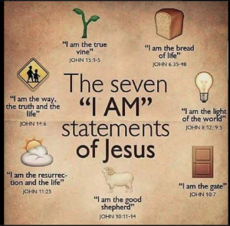  April 2020  Tuesday  ‘I am the gate’  We pray for those who work in local services to keep us all safe.  *  Wednesday  ‘I am the way, the truth and the life’  We pray for our local and national politicians and those who are making decision that will shape our lives for years to come.

