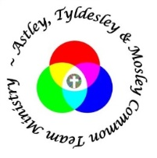
St George’s Families @ Four
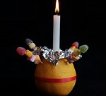
Join us for our Christingle Event
Advent Sunday 1st December
Jesus said,
‘I am the light of the world’

