Astley, Tyldesley and Mosley Common Team – Newsletter:
August 2019
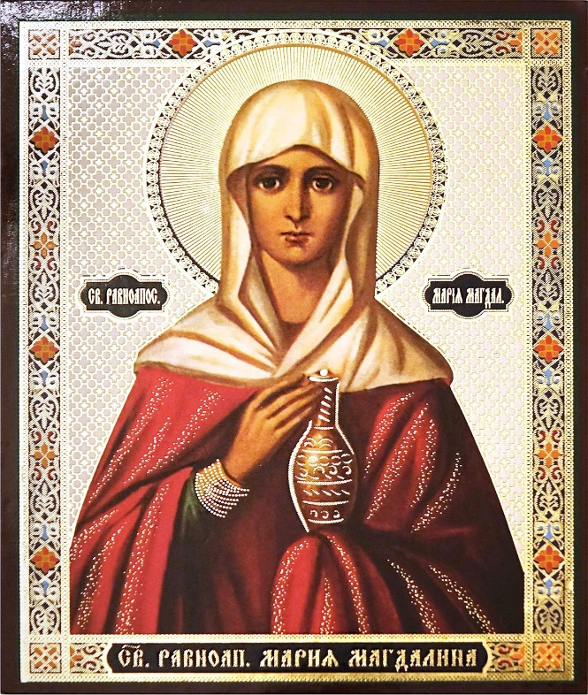
Collect for Mary of Magdala

Almighty God, whose Son restored Mary of Magdala to health of mind and body and called her to be a witness to his resurrection: forgive our sins and heal us by your grace, that we may serve you in the power of his risen life; who is alive and reigns with you and the Holy Spirit, one God, now and forever. Amen.

Please do not forget!
More than Sunday - a year of discipleship. For monthly inspiration and ideas, sign up at: www.manchester.anglican.org/more-than-Sunday/

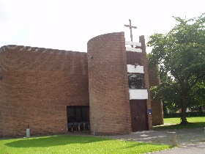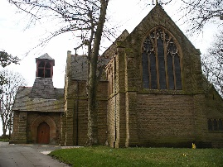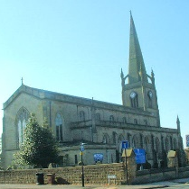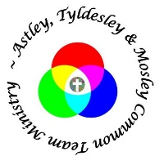

Information
Please send information to Iain Hodcroft, iain.hodcroft@gmail.com (07976 314012): or Susan Mallon, atmcteamclerk@gmail.com ( 07873 149627)
Thank you to everyone that contributed to accuracy of August issue.

Diary of Services

 | St Stephen | St George | St John
Sun 28 July  Trinity 6 | Holy Communion 8.00am  Rev P Brody  Holy Communion  9.30am  Rev A Dand/  Rev B Cox to preach | Morning Prayer 8.00am  D Kerfoot  Sung Eucharist  10.30am  Rev M Cox  Holy Baptism  12.15pm  Rev M Cox | Holy Communion  10.00am
Tue 30 July |  |  | Place of Welcome  10.00am-12.00
Wed 31 July | Holy Communion 11.30am  Rev M Williamson
Fri 2 August |  | Team Prayer 9.30am  Place of Welcome  10.00am
Sat 3 August | Wedding  1.00pm  Rev Paul Brody
Sun 4 August Trinity 7 | Morning Prayer 8.00am  D Kendrick  Holy Communion 9.30am  Rev M Cox | Holy Communion 8.00am  Rev P Brody  All Age Worship 10.30am  Cath Eccles/David K | Morning Worship  10.00am  D Kendrick
Tue 6 August |  |  | Place of Welcome  10.00am-12.00
Wed 7 August | Holy Communion 11.30am  Rev M Cox
Fri 9 August |  | Team Prayer 9.30am  Place of Welcome  10.00am
Sat 10 August | Stepping Up  (Baptism Families and guests) 3.30pm
Sun 11 August  Trinity 8 | Holy Communion  8.00am  Rev P Brody  Worship Together  9.30am  K. Revell/D. Clarke | Morning Prayer  8.00am  D.Kerfoot  Sung Eucharist  10.30am  Rev P Brody  Holy Baptism  12.15pm  Rev M Cox | Holy Communion 10.00am  Rev M Cox
Tue 13 August |  |  | Place of Welcome  10.00am-12.00
Thurs 15 August | Meeting Point with H/ C.  1.30pm  Rev M Williamson
Fri 16 August |  | Team Prayer 9.30am  Place of Welcome  10.00am
Sun 18 August  Trinity 9 | Morning Prayer  8.00am  D Kendrick  Holy Communion 9.30am  Rev A Dand/??  Holy Baptism  2.30pm  Rev A Dand | Holy Communion  8.00am  Rev P Brody  Sung Eucharist  10.30am  Rev P Brody | All Age Worship  10.00am  D Kendrick
Tue 20 August |  |  | Place of Welcome  10.00am-12.00
Wed 21 August | Holy Communion 11.30am  Rev D Connolly
Fri 23 August |  | Team Prayer 9.30am  Place of Welcome  10.00am
Sun 25 August  Trinity 10 | Holy Communion  8.00am  Rev D Connolly  Holy Communion  9.30am  Rev D Connolly | Morning Prayer  8.00am  D Kerfoot  Sung Eucharist (All Age)  10.30am  Rev A Dand  Holy Baptism  12.15pm  Rev A Dand | Holy Communion  10.00am  Rev M Williamson /Mrs J Williamson
Tue 27 August |  |  | Place of Welcome  10.00am-12.00
Wed 28 August | Holy Communion 11.30am  Rev M Cox
Fri 30 August | “Grave Talk”  (see text)  2.30pm -4.00pm  Debbie Clarke/Diane Leakey | Team Prayer 9.30am  Place of Welcome  10.00am

Sun 1 September  Trinity 11 |  | “Big Lunch” at Shakerley Community Centre  See text
Sat 7 September | Confirmation Preparation Day  10.00am – 4.00pm  Bring your own lunch! (drinks provided)

Please forward information for September to atmcteamclerk@gmail.com by Monday 19 August 2019

  - “Meeting Point” at St Stephen’s Church
Meeting Point is a group of Parishioners who meet on the 3rd Thursday each month in Church. The idea was started several years ago with the intention of providing transport for those parishioners who found it very difficult to get to church for the usual Sunday Services. We start at 1.30pm with a Holy Communion Service and this is followed by afternoon tea, finishing at about 3.00pm.

We continue to meet regularly each month under the guidance of Rev Martin Cox and Rev Michael Williamson.

We are always happy to welcome anybody who may care to join us each month. Should you require help with transport to St Stephen’s Church, please see the list at the back of your church and we will do our best to provide the help you may need.

The dates for the next few months are:
19th September at 1.30pm
17th October at 1.30pm
21st November at 1.30pm
19th December at 12 noon [please note change of time for this month]
We look forward to you joining us at St Stephen’s Church.

Should you require any further information please do not hesitate to contact me – Jean Russell on 0161 975 7857

“Where everyone is welcome and people come together”

  - “Grave Talk”
The truth is that we are all going to die but nobody wants to say anything!

This Grave Talk session aims to encourage us to consider death, an aspect of our lives we may not always like to think about.

Having the opportunity to talk about death, dying and funerals helps us to articulate our own thoughts and feelings, to ask questions and to share our experiences in a relaxed cafe style environment.

This is an informal setting designed to provoke conversation around life, death, society, funerals and grief.

There will be tea, cake and hopefully lots of chat.

The first 'Grave Talk' session to take place on 30th August from 14:30 to 16:00 at St Stephen's.

The first session is for our congregations so that we can get a feel of how to run it and then we hope to expand into the community.

‘Sign Up’ sheets will be at the rear of all three churches, with up to 10 places being available. per church.

Advance notice.
Saturday 12 October, 10.00am – 4.00pm at Christ Church Pennington Leigh.
Bereavement Care Awareness Day run by Care for the family for anyone interested in supporting bereaved people.
The cost is £15.00, three paid places are available for our team for those interested in attending the day.
You will need to take a packed lunch; tea and coffee will be provided. Anyone interested please contact Diane Leakey 0161 703 8076 as we need to book places.

  - The Big Lunch
Bringing people together
1 in 5 people in the UK have never spoken to their neighbours!
New research has identified a widening gap in the relationship between people and their neighbours that is damaging our mental and physical health.
The Big Lunch is a very simple idea …
The aim is to get as many people as possible across the whole of the UK to have lunch with their neighbours in a simple act of community, friendship and fun.
The Eden Project launched this initiative and it is growing year by year. Most events take place in June, but Shakerley Community Partnership decided on a September date, before children return to school, and as an early ‘Harvest’ celebration!
Come and join us at the Community Centre from 12.00 – 2.30pm
“Use
this
space”
Tell us your thoughts, promote your activities, share ideas about future initiatives.

Astley, Tyldesley and Mosley Common Team Ministry

“Rooted in God’s love,
Growing together with Jesus,
Ministering in the power of the
Holy Spirit.”

