Bible story; Daniel and the Lions
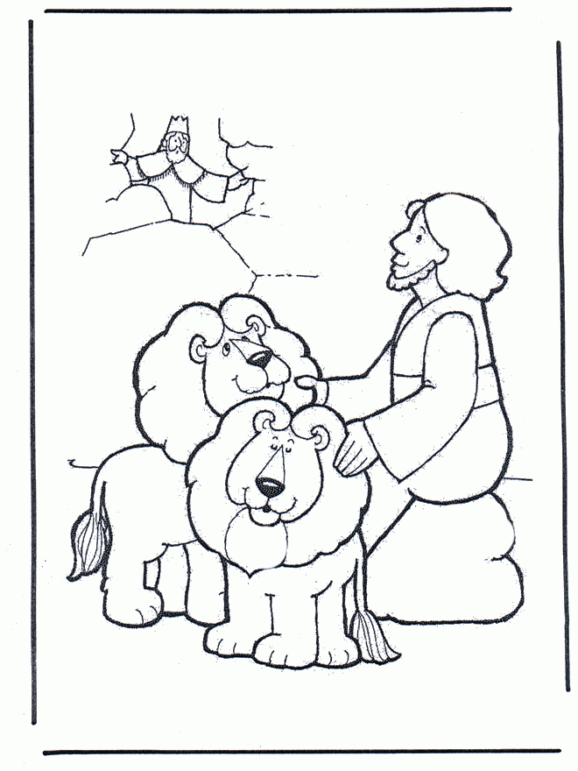

This is a story about Daniel. He came to Babylon with Shadrach, Meshach, and Abednego, and each king that came and went liked these men because they were honest and hard workers. They were always given the most important jobs which made the other workers of the king jealous. This time the king's name was Darius and he also liked Daniel. He knew that Daniel was a good worker so he decided to put Daniel in charge of the whole country. The other servants of the king were very jealous of Daniel and they tried to find something that would get Daniel in trouble. They were trying to get him fired, but Daniel obeyed God
so they couldn't find anything.
Finally these men said to each other, "We can't find any reason for the king to fire Daniel. The only way we could get him to disobey the king is if we made a law against his god." So they went to king Darius and said, "O great king, you are so wonderful that no one should pray to anyone but you." The king said, "That sounds like a great idea!" Then the men continued, "All of your workers have agreed that this should be done and that anyone that prays to any other god should be thrown into the lions den." The workers lied and said that everyone who worked for the king agreed, but of course they never talked to Daniel because they knew he wouldn't agree. The king didn't know this, so he made the law and it couldn't be changed.
When Daniel heard about the new law he did what he always did. He went home to a room upstairs and opened the windows that looked out over the city. Three times that day he went down on his knees and prayed to God just like he always had. These men went as a group to Daniel's house and found him praying and asking God for help. So they ran straight to the king and told him, "Your worker Daniel is ignoring your command. We have seen him praying to his God three times today." When the king heard this he was very sad. He really liked Daniel and he didn't want him to die. He tried everything to get the law changed to stop Daniel from being thrown in the lions' den, but the men came to him and reminded him that the law could not be changed and Daniel would have to be punished.
So at the end of the day the king gave the order, and they brought Daniel and threw him into the lions' den. The king said to Daniel, "I hope your God who you serve and pray to will rescue you!" A large, heavy stone was rolled in front of the den and the king went back to his palace with tears in his eyes. That night King Darius couldn't eat or sleep he was so worried for Daniel.
The next day, as soon as the sun came up the king got up and ran to the lions' den. As he got closer he shouted, "Daniel, has your God who you serve and pray to rescued you from the lions?" The king waited quietly for a response. Then all of a sudden Daniel said, "O king, live forever! My God sent an angel, and he shut the mouths of the lions. They have not hurt me because I have done nothing wrong." The king jumped with joy and immediately ordered that Daniel be removed from the den. And when Daniel was lifted from the den, there wasn't even a scratch on him because he trusted in God.
The king knew that the men had tricked him into punishing Daniel so he punished them.
After that the king made a new law and he said, "Daniel's God is great, and I order that everyone in my kingdom must respect the Lord God, who rescued Daniel from the hungry lions."

