**From the Mosley Common Magazine Archives** (Andrea M Taziker)

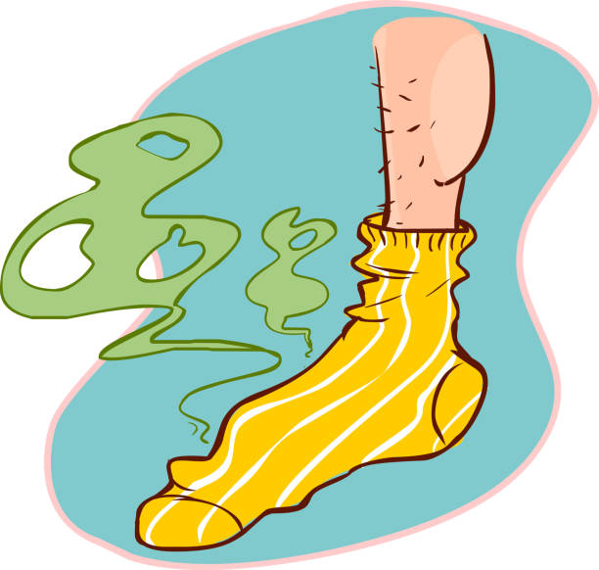

**March 1939**

**Painful feet in hot weather**

First get a piece of old linen such as a piece of a sheet or pillow slip, but it must be linen. From this make a pair of socks to fit the feet. Melt half a pound of best kidney suet in the oven, dip the socks in it and allow them to get well soaked, put on when just cool. wear these every day for a week or two, without washing feet whilst undergoing this treatment. If the socks wear out quickly, make another pair. They are not pleasant to wear at the time, but the sufferers will find the cure worth it.

(Mrs E Rickrett )

*( I am not sure the smell from ones feet for 2 weeks in kidney suet would make the cure worth it!)*

**July 1938**

**HAIR-SETTING LOTION**

Mix the white of an egg with 4 parts water. This is excellent and also a tonic for the hair. (K. Fancourt)

*(I would imagine this would smell, and kind of fry in hot weather?!)*

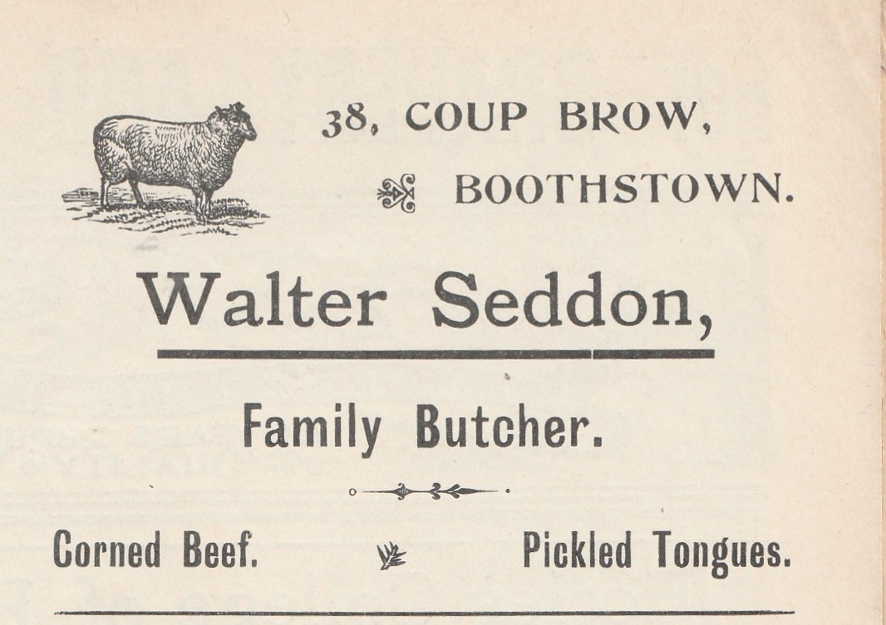

**August 1938 from Robert Kee, the Vicar.**

Everyone has his or her opinion how things should be done in a parish, and I suppose it is unfortunate to a degree that the Vicar should be responsible. Clergymen generally are, in the eyes of the laity, stupid, selfish and stubborn animals, it is really tragic that they were all once the laity, or part of that infallible multitude. The clergy really only look stupid because they endeavour to please everybody, no human being could do that. Personally, I do not make the least endeavour to please anybody, I just try to be fair. Stories or second hand complaints never perturb me in the least. So that you, kind friend, if you have a complaint to make, make it directly to me, as the unfortunate person responsible, and I will, if it is at all reasonable make every endeavour to adjust the matter to the agreeable liking of the complainant

**July 1938**

**A USE FOR OLD TELEPHONE DIRECTORIES**

Place a picture from a flower catalogue on the cover and place near the kitchen sink. It will be handy if a piece of paper is required to wipe grease from knives, etc before putting them in the wash-up bowl. (Auntie Annie)