LET THERE BE LIGHT
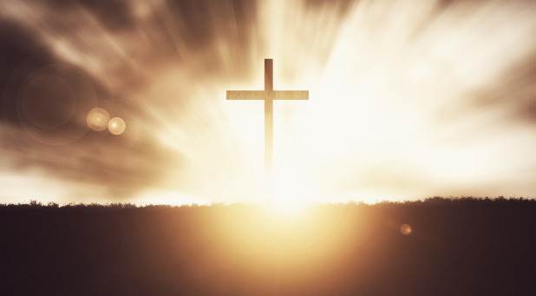

And God said “Let there be light”, and there was light (Genesis 1:3)
God of radiance, source of all light:
Let there be light in my eyes, so I can see the truth more clearly,
Let there be light in my mind so I can know your goodness more closely,
Let there be light in my heart so I can love this world more fiercely.

Let there be light in my body so I can experience your creation more fully,
Let there be light in my soul so I can follow your path more freely,
Let there be light in my community so we can accept each other more openly.

Let there be light in the church so we can do your will more obediently,
Let there be light in my country so we can live more peacefully,
Let there be light in the world so all can have life more abundantly.
In Jesus name, Amen

Gideon Heugh of St Stephens
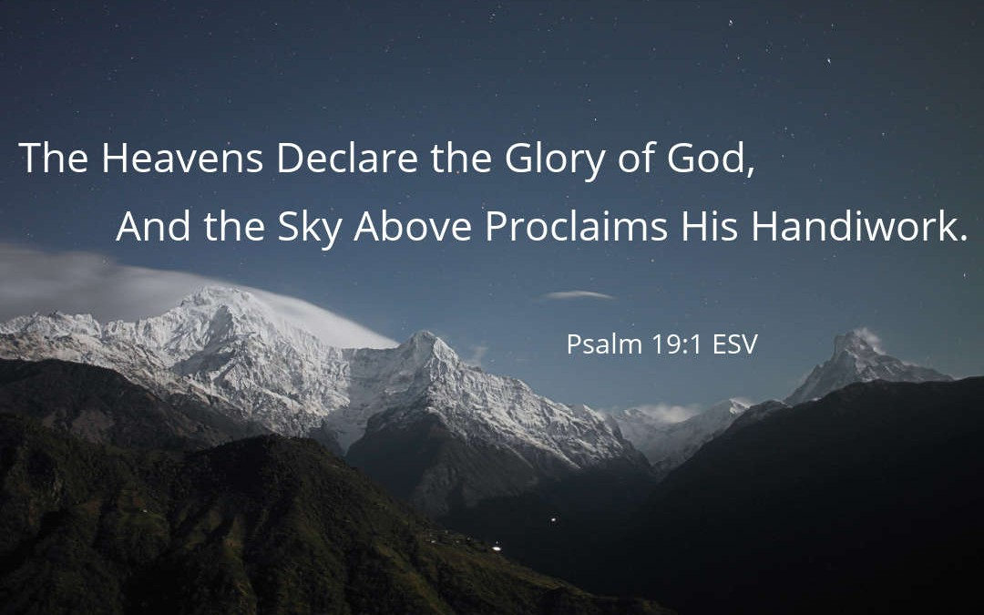

Creations glory
In Romans Chapter 8 verse 19 we read “The creation waits in eager expectation for the children of God to be revealed”. It is part of a section about the looking forward to when all is complete, everything restored to eternal life. Decay and destruction has ceased because of the victory of Christ. The glory of Christ is revealed in us.
Perhaps we ought to think more about how the creation, of which we are a part, is linked to our own new life in Christ? If we become more Christ-like, then the whole of creation will be set a little more free!
O God of creation show me today I am part of your family. Transform and remake me so that all your creation will be a little more free. Amen
Michael of St Stephens

Around the world thousands of Christians have been self-isolating for years – not because of any biological virus, but because their faith is condemned, outlawed and seen as dangerous to the State. These countries include North Korea, Afghanistan and Somalia. There, if discovered, you could be sent to labour camps, prison or killed.

These Christians often have to keep their faith secret and only meet in small groups. Listening to Christian themed programmes on the radio, reading religious literature or sourcing information on technology is all done in secret.

Open Doors works in over 60 countries, supplying Bibles, training church leaders, providing practical support and emergency relief, and supporting Christians who suffer for their faith. In the UK and Ireland Open Doors works to raise awareness of global persecution, mobilising prayer, support and action among Christians.

For those suffering because of their Christian faith, we pray that the Holy Spirit may fortify them with the courage to remain strong in faith, as well as with the charity to forgive their persecutors, we pray to the Lord.
Michael of St Stephens

