# ECO DIOCESE: HELP US OVER THE LINE!



### Assess

### Celebrate

your achievements

### Decide

your next steps

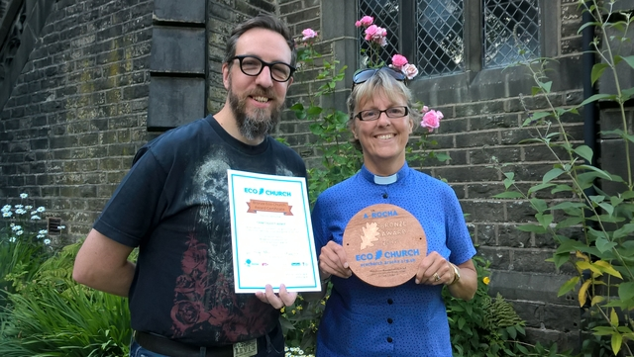

Manchester Diocese has been on a journey to become an Eco Diocese, which means taking seriously our care of God's creation and making it part of our everyday lives. We are now just one church short of meeting a key criterion for Eco Diocese status.

When we launched the A Rocha UK Eco Church programme in 2018 we set ourselves two targets:

32 churches registered for Eco Church (10%)

16 churches with a Bronze award (5%)

We exceeded easily the first target by Easter 2019. Hard work led to ten churches receiving Bronze and Silver awards, but by March 2020 we were still short of the second. Given the energy needed to meet new challenges, a decline in Eco Church activity under lockdown might have been predicted. Yet it’s amazing what our churches have achieved. Since our buildings closed their doors five churches have reported Eco Church awards: Silver for St John, Pendlebury and St Maxentius, Bradshaw and Bronze for Holy Trinity, Dobcross, Sacred Trinity, Salford and St Anne, Edgeside.

Manchester is now one award short of meeting a key criterion for Eco Diocese status.We also have 50 churches working towards becoming an Eco Church. If your church is registered, although award applications are temporarily closed for six weeks, you can check your progress against the Eco Church survey. Could your church be the one that takes Manchester across the finishing line?

To find out if your church is registered for Eco Church visit: <https://app.ecochurch.org/map>

To view the Eco Church survey visit: <https://ecochurch.arocha.org.uk/how-eco-church-works/>

For help and support with Eco Church, please contact [Alison Peacock](mailto:alisonpeacock@manchester.anglican.org) or Diocesan Environmental Officer, [Revd John Hughes](mailto:environment@manchester.anglican.org).

**Your Church, caring for God's Earth**

The science is clear. Our Planet is in trouble. Climate change threatens the delicate equilibrium that sustains life and biodiversity is collapsing around the globe. We must act now if we are to leave our children a planet worth inheriting. There is still a glimmer of hope. God chooses to use His people in His redemption story. We have a part to play. But where to start? How do we know which actions will have the most effect? And how do we bring the rest of our churches with us?

Eco Church is A Rocha's tool to help your church celebrate what you already do well and make informed decisions about what to do next.

Do join us and become part of a growing network of churches caring for God's earth.