**CHURCH SERVICES**

**Sundays**

8.15am Holy Communion (Book of Common Prayer)

10.15am Family Communion (Common Worship) - with Sunday Club and Crèche (followed by tea or coffee fellowship)

6.00pm Evensong

**Healing**

A Healing Service will be held on the 1st Sunday of each month during the 8.15am communion service and also at 10.15am.

**Baptisms**

Baptisms will take place (by prior arrangement) at 12 noon, second and forth Sunday of every month. The November service is held on the third Sunday only To arrange a Baptism see Mr. Keith Houghton MBE after the 10:15 am service (approx 11:30am) ( 01942 797838).

There will be no Baptisms in Lent.

**Arrangements for Weddings**

For weddings, parishioners should see Rev. Martin Cox at the Vicarage. Please telephone and make an appointment in advance (01942 883313) .

**Pastoral Needs and Visits**

Parishioners with pastoral needs (requests for counselling, personal problems or advising of illness) or any request of an urgent nature should contact the vicarage direct on telephone 01942 883313.

Housebound sick communions can also be undertaken and any parishioner not presently on the sick communion list, who wishes to be considered to receive such a visit, should advise clergy accordingly.

***Martin, our Team Rector, has a rest day towards the end of each week. Please make contact with him as you need to on 01942 883313 and he will respond to you as speedily as he can.***

**St. George’s Church**

We now have a website for you to use, with lots of up to date and interesting information. We welcome your feedback.

http://www.tyldesleystgeorge.co.uk

**The Parish Church of**

**St. George, Tyldesley.**

**June 2017**



Parish News

**OFFICIALS**

**Team Rector: Rev. Martin B Cox**

7 Holbeck Astley M29 7NL

***01942 883313***

**Team Vicar: Rev. Julian Hartley**

St. John’s Vicarage, Mosley Common

***0161 790 2957***

**Ordained Local Rev. Angela J Dand**

**Minister: *01942 879608***

**Ordained Pioneer Rev. Jan Harney**

**Minister: *01942 671481***

**Reader : Mr. David Kerfoot**

***01942 870736***

**Churchwarden: Mrs. Kathleen Topping**

***01942 884746***

**Treasurer Mr. Jonathan Jones**

**07971 616263**

**“Together in worship, love and service”**

**June Edition 2017**

Dear friends

Following the Prime Minister’s decision to call a ‘snap’ General Election for Thursday 8th May political parties across our country have been busy putting together their manifestos. These are the carefully crafted written documents that set out their ideas and priorities for government should they have sufficient number of MPs elected at the General Election. As it happens, I am writing this article in the week that the three main UK political parties are ‘launching’ their manifestos.

Our Lord Jesus had a manifesto. Jesus spent quite a lot of time preparing for its launch, which was preceded by his baptism and temptations in the wilderness. In Chapter of his gospel, Luke records the following in his account of the beginning of Jesus’ public ministry.

Then Jesus, filled with the power of the Spirit, returned to Galilee, and a report about him spread through all the surrounding country. He began to teach in their synagogues and was praised by everyone.

When he came to Nazareth, where he had been brought up, he went to the synagogue on the Sabbath day, as was his custom. He stood up to read, and the scroll of the prophet Isaiah was given to him. He unrolled the scroll and found the place where it was written:

‘The Spirit of the Lord is upon me,  
    because he has anointed me  
        to bring good news to the poor.  
He has sent me to proclaim release to the captives  
    and recovery of sight to the blind,  
        to let the oppressed go free,  
to proclaim the year of the Lord’s favour.’

**From the Registers April 2017**

|  |  |  |  |  |  |  |  |  |  |  |  |  |  |  |  |  |  |  |  |  |  |  |  |  |  |  |  |  |  |  |  |  |  |  |  |  |  |  |  |  |  |  |  |  |  |  |  |  |  |  |  |  |  |  |  |  |  |  |  |  |  |  |  |  |  |  |  |  |  |  |  |  |  |  |  |  |  |  |  |  |  |  |  |  |  |  |  |  |  |  |  |  |  |  |  |  |  |  |  |  |  |  |  |  |  |  |  |  |  |  |
| --- | --- | --- | --- | --- | --- | --- | --- | --- | --- | --- | --- | --- | --- | --- | --- | --- | --- | --- | --- | --- | --- | --- | --- | --- | --- | --- | --- | --- | --- | --- | --- | --- | --- | --- | --- | --- | --- | --- | --- | --- | --- | --- | --- | --- | --- | --- | --- | --- | --- | --- | --- | --- | --- | --- | --- | --- | --- | --- | --- | --- | --- | --- | --- | --- | --- | --- | --- | --- | --- | --- | --- | --- | --- | --- | --- | --- | --- | --- | --- | --- | --- | --- | --- | --- | --- | --- | --- | --- | --- | --- | --- | --- | --- | --- | --- | --- | --- | --- | --- | --- | --- | --- | --- | --- | --- | --- | --- | --- | --- | --- |
| **Date Service Communicants Children Adults**   |  |  |  |  |  | | --- | --- | --- | --- | --- | | 2nd | Holy Communion | 6 |  | 6 | |  | Sung Eucharist | 41 | 2 | 43 | |  | Evening Prayer |  |  | 1 | | 9th | Holy Communion | 6 |  | 6 | |  | Sung Eucharist |  |  |  | |  | Team Service |  |  | 30 | | 10th | Funeral |  | 2 | 78 | | 14th | At the foot of the Cross |  |  | 8 | | 16th | Holy Communion | 7 |  | 7 | |  | Worship Together | 47 | 4 | 49 | |  | Evening Prayer |  |  | 3 | | 21st | Funeral |  |  | 36 | | 23rd | Holy Communion | 8 |  | 9 | |  | Sung Eucharist | 44 |  | 45 | | 25th | Funeral |  |  | 50 | | 30th | Holy Communion | 8 |  | 8 | |  | Sung Eucharist | 42 | 1 | 42 | |  | Evening Prayer |  |  | 2 | |  |  |  |  |  | |  |  |  |  |  | |  |  |  |  |  | |  |  |  |  |  | |

**Collection Totals April 2017**

|  |
| --- |
| **Cash Cash GA Planned Giving GA Planned giving**  £444.93 £0.00 £795.00 £530.00  **Regular anonymous gift to the Restoration Fund**  £10-00 / per week  **Donations** £10.00 **Organ** £20.00 |



**June Flower List**

"We thank the following members of the congregation for Altar flowers in June"

4th June. "Open for offers"

11th June. "Open for offers"

18th June. Mrs J Grundy

25th June. Legacy of Mr Clifford Cook

On the 7th May Altar flowers were provided in Loving Memory of Hilda and Stanley Gill from their daughter Marian. We thank you very much.

On 21st May , Altar flowers were provided in Loving Memory of Patricia Taylor from her mother Clara, husband Alan, sister Helen and grand daughter Natasha. Many thanks.

Thank you to everyone who has supported the Flower fund during May. L.F.

And he rolled up the scroll, gave it back to the attendant, and sat down. The eyes of all in the synagogue were fixed on him. Then he began to say to them, ‘Today this scripture has been fulfilled in your hearing.

As with all launches of manifestos, this didn’t go down too well with everybody. In fact, the text tells us that Jesus was rejected by some even at the beginning of his ministry – the word ‘rejection’ being a hard word that leaves no room for doubt as to the feelings of some around him.

The Revd Dr Sam Wells has been the Vicar of St Martin-in-the Fields since 2012. Amongst the books he has written is a book entitled, *A Nazareth Manifesto.* It is an eloquent and impassioned ecumenical proposal for re–envisioning Christianity’s approach to social engagement away from working for the people to being with them. Dr Wells questions the effectiveness of the current trend of intervention as a means of fixing the problems of people in distressed and disadvantaged circumstances. The basis of his argument on the insight we gain from all four gospels (John 4 for example) is that Jesus spent 90% of his life simply being among the people of Nazareth, sharing their hopes and struggles, therefore Christians should place a similar emphasis on being alongside people in need rather than hastening to impose solutions.

Beyond our personal party political allegiances, I wonder if this is a book you could purchase a read alongside the manifestos and handbills that will be delivered to you over the next few weeks and beyond as we seek to live Christ-like lives in the twenty-first century ?

Yours in His service

Martin

Revd Martin Cox

Team Rector

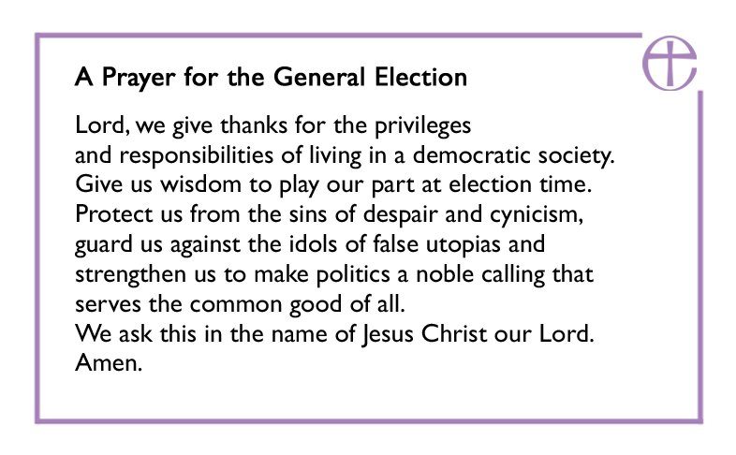

**Consolation**

To the family of

Janet Gould

*May she rest in peace and rise in glory*

**Welcome to the Family**

Kory George Lonsdale   (BABY)

Rory Jonathon Lonsdale (ADULT)

Michael Carl Richard Horner  (ADULT)

Thomas Jones   (ADULT)

Charlene Richards  (ADULT)

*Newly Baptised*

Our grateful thanks go to Mrs Agnes Smith for her kind donation of £200.00 to our Restoration Fund.

Our sincere thanks go to the Friends of St. George’s for the donation of £200.00 for the sale of Easter Pots.  Again we are most grateful for all the hard work carried out in making these.

The sum of £130.00 + Gift Aid was donated to the Lent Appeal in aid of the Church Urban Fund and Lifeboat Association. Thankyou to everyone who donated.

Kath

**News From St. Stephens**

**At last – we’ll be Raising the Roof!!**

At long last, after many years of hard work fund raising and many hours of discussion with architects and builders, contractors will be moving on site at the beginning of June to begin work on replacing the church roof.

Inevitably there will be some disruption to our common life together but this will be kept to a minimum. There will need to be vigilance around the church building as work progresses. The initial phase will be the erection of scaffolding, which itself will take some time to put up.

We will communicate regularly with updates. Please route any queries or concerns about the building work directly to either of our churchwardens or myself rather than to the workmen themselves as it is important that we have a clear communication channel with the contractors.

Thank you for your understanding

Revd Martin Cox, Team Rector.

**ANNUAL CHURCH MEETINGS – ELECTION RESULTS.**

At our annual Church meetings which took place within the 10.15am Said Eucharist in St. George’s church on Sunday 23rd April 2017, the following persons were elected/appointed to serve in the positions and for the terms of office as indicated**:**

**CHURCHWARDENS (for 2017-8)**

Mrs. Kathleen Topping

**PCC MEMBERS (for 2017-8)**

Mrs. Elizabeth Brundrett Mr. Alan Murgatroyd

Ms. Claire Campbell Mr. David Kerfoot

Mr. Alan Cross Ms. Ruth Kerfoot

Mrs. Audrey Hayes Mr. John Lemon

Mrs. Margaret Hook Mrs. Jean Pearson

Ms. Christine Howell Ms. May Preston

Ms. Susie Mallon

**DEANERY SYNOD REPRESENTATIVES (for 2017-20)**

Mr. IaIn Hodcroft

**SIDESPERSONS (for 2017-8)**

Mr. Geoffrey Hilton

Mrs. Margaret Hook

Ms. Ruth Kerfoot

Mr. John Lemon

Mr. Alfred Osborne

**INDEPENDENT EXAMINER (for 2017-8)**

Mr. David McCormick

**Please remember them in your prayers, that through their ministries St. George’s will be blessed.**

**David**